Ti-Plasmids
Crown gall is a neoplastic disease of most dicotyledonous plants and is caused by the soil bacterium Agrobacterium tumefaciens. A large extra-chromosomal plasmid in these bacteria was found to be responsible for its tumor-inducing capacity and was, therefore, called Ti-plasmid.
Ti plasmids are large, often more than 200 kb long, catabolic plasmids . A Ti plasmid can be transferred by conjugation to most Agrobacterium and some Rhizobium species.
A major characteristic of a Ti plasmid is that it contains, the vir or virulence genes, which enable a copy of one or more segments (T-DNA) of the Ti plasmid be transferred into plant cells, where it can become integrated into the plant genome.
The genes encoded by the T-DNA are under eukaryotic control and can be expressed in a plant background. This can result in a plant cell proliferation (crown gall formation) and the synthesis and secretion of a specific metabolite, of no use for the plant. These metabolites, called opines, are condensation products of amino acids, such as arginine and lysine, and abundant plant metabolites such as pyruvic acid, ketoglutaric acid, succinate, and mannose.
Thus, crown gall disease is a naturally evolved genetic engineering process. Crown gall formation is the consequence of the transfer integration and expression of genes of T-DNA of A. tumefaciens in the infected plant.
Organization of Ti plasmid
The Ti plasmid has three important region:-
- T-DNA region: This region has the genes for the biosynthesis of auxin (aux), cytokinin (cyt) and opine (ocs), and is flanked by left and right borders. } T-DNA borders- A set of 24 kb sequences present on either side (right & left) of T- DNA are also transferred to the plant cells. It is clearly established that the right border is more critical for T-DNA transfer.
- Virulence region: The genes responsible for the transfer of T-DNA into host plant are located outside T-DNA and the region is reffered to as vir or virulence region. At least nine vir-gene operons have been identified. These include vir A, vir G, vir B1, vir C1, vir D1, D2, vir D4 and vir E1, E2.
- Opine catabolism region: This region codes for proteins involved in the uptake and metabolisms of opines.
- Besides the above three there is ori region that responsible for origin of DNA replication which permit the Ti plasmid to be stably maintain in A. tumefaciens.
Structure of Ti plasmid

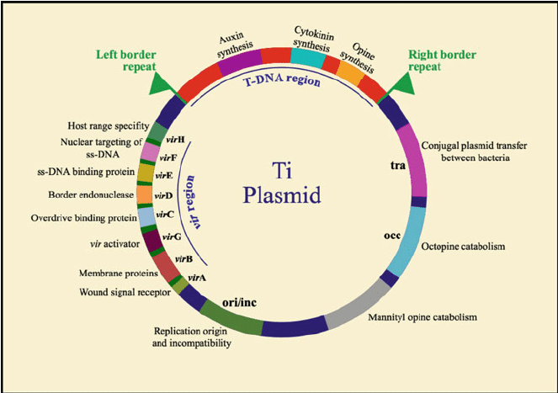

The process of T-DNA transfer and it integration into the host plant genome are as follows: -
- Signal induction to Agrobacterium: - The wounded plant cells release certain chemicals-phenolic compounds and sugars which are recognized as signals by Agrobacterium. The signals induced result in a sequence of biochemical events in Agrobacterium that ultimately helps in the transfer of T-DNA of T-plasmid.
- Attachment of Agrobacterium to plant cells: - The Agrobacterium attaches to plant cells through polysaccharides, particularly cellulose fibres produced by the Bacterium.
- Production of virulence proteins: - As the signal induction occurs in the Agrobacterium cells attach to plant cell, a series of events take place that result in the production of virulence proteins. To start with, signal induction by phenolics stimulates vir A which in turn activates (by phosphorylation) vir G. This induces expression of virulence gene of Ti-plasmid to produce the corresponding virulence proteins (D1, D2, E2, B etc.).
- Production of T-DNA strand: - The right and left borders of T-DNA are recognized by vir D1/vir D2 proteins. These proteins are involved in the production single-stranded T-DNA (ss DNA), its protection and export to plant cells. The ss T-DNA gets attached to vir D2.
- Transfer of T-DNA out of Agrobacterium: - The ss T-DNA –vir D2 complex in association with vir G is exported from the bacterial cell. Vir B products form the transport apparatus.
- Transfer of T-DNA into plant cells and integration: - The T-DNA –vir D2 complex crosses the plant plasma membrane.In the plant cells, T-DNA gets covered with vir E2. This covering protects the T-DNA from degradation by nucleases. Vir D2 and vir E2 interact with a variety of plant proteins which influences T-DNA transport and integration. } The T-DNA – vir D2, vir E2- plant protein complex enters the nucleus through nuclear pore complex. Within the nucleus, the T-DNA gets integrated into the plant chromosome.
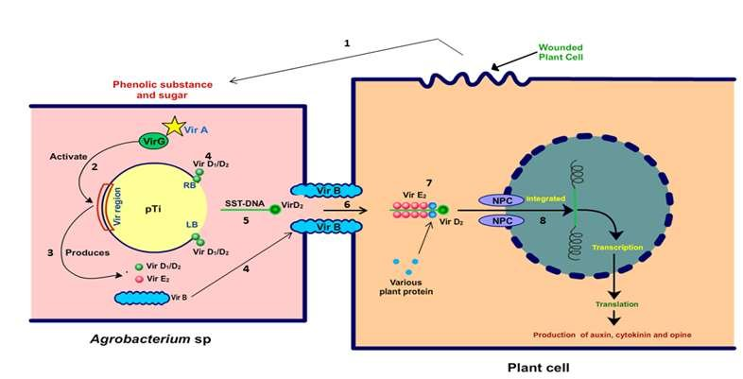
References
- Life Sciences by Pranav Kumar and Usha Mina Pathfinder publication.

